A PROJECT REPORT
on
DABBEWALE: A tiffin service management system.
Submitted by
Ms. Ishwari Shinde
And
Mr. Kaustubh Rane
in partial fulfillment for the award of the degree
of
BACHELOR OF SCIENCE
in
COMPUTER SCIENCE
under the guidance of
Prof. Vipul Saluja
Department of Computer Science

R. D. & S.H. National College & S. W. A. Science College
Bandra, Mumbai – 400050.
(Sem V)
(2025 – 2026)



R.D. & S.H. NATIONAL COLLEGE

& S. W.A. SCIENCE COLLEGE,
Bandra, Mumbai – 400050.
Department of Computer Science

PROJECT CERTIFICATE

This is to certify that Ms. Ishwari Shinde and Mr. Kaustubh Rane of T.Y.B.Sc. (Sem V) class has satisfactorily completed the Project entitled Dabbewale, to be submitted in the partial fulfillment for the award of Bachelor of Science in Computer Science (Semester V) during the academic year 2018 – 2019.
It is further certified that the project is an original work and it has not formed the basis for the award of any degree, associateship, fellowship or any other similar titles.
Date of Submission:

Internal Project Guide Co-ordinator,
Department of Computer Science

Signature of External Examiner

DECLARATION

I, ______________________________, hereby declare that the project entitled “Dabbewale” submitted in the partial fulfillment for the award of Bachelor of Science in Computer Science during the academic year 2025 – 2026 is my original work and the project has not formed the basis for the award of any degree, associateship, fellowship or any other similar titles.

Signature of the Student:

Place:

Date:

Acknowledgment
We would like to sincerely thank our teachers—Vipul Sir, Sufiya Ma’am, Madhavi Ma’am, Farheen Ma’am, and Avinash Sir—for their valuable guidance, encouragement, and support throughout the development of our Dabbewale project. Their inputs helped us improve our work and overcome many challenges.

We are also grateful to Verma Sir and Prashant Sir for their kind assistance and support, which made our journey smoother. A special thanks goes to our friends for their feedback and to our families for their constant motivation and belief in us.

Working together on this project has been a rewarding experience, teaching us not only technical skills but also teamwork, patience, and problem-solving. We truly appreciate everyone who contributed to making this project possible.

Index
I. Preliminary Investigation
(i) Synopsis
(ii) Organizational Overview
(iii) Working of the Current System
(iv) Limitations of the Current system
(v) The Proposed System
(vi) Advantages of the Proposed System
(vii) Tools and Technologies to be Used
(viii) Feasibility Study
II. System Analysis
(i) Event Table
(ii) Use Case Diagram
(iii) ERD
(iv) Activity Diagram
(v) Class diagram
(vi)Object Diagram
(vii) Sequence diagram
(viii) Collaboration Diagram
(xii) State diagram
III. System Design
(i) Component Diagram
(ii) Package Diagram
(iii)Deployment Diagram
(iv)System flow chart
(v) Structured Chart
IV. System Coding
(i) Menu Tree / Sitemap
(ii)Data Dictionary
(iii) Design Patterns used
(iv)Source Code

V. System Implementation
(i) H/W and S/W Requirements
(ii) Screen / Report Layouts
VI. Future Enhancements
VII. References and Bibliography
VIII. Annexures
i) Proposal
ii) Phase Completion Table
iii) Gantt Chart

I. PRELIMINARY INVESTIGATION

DabbeWale - Project Synopsis
1.Title
DabbeWale: A Digital Platform for Home-Cooked Meal Delivery Services

2.Introduction
DabbeWale is a web-based platform designed to bridge the gap between local home-cooked meal providers and consumers seeking authentic, nutritious, and affordable food options. The platform provides a convenient access to homemade meals while supporting local communities and traditional cooking practices.

3.Objectives
- Allow users to sign up and browse available tiffin services
- Enable tiffin service providers to register and list their meal plans
- Provide location-based search to find nearby food providers
- Let users contact or book tiffin services directly

4.Scope
- User Management: Registration, authentication, and profile management for both consumers and providers
- Provider Discovery: Location-based search and filtering of tiffin service providers
- Order Management: Complete order lifecycle from placement to delivery tracking
- Menu Management: Dynamic menu creation and management for providers
- Payment Integration: Secure payment processing for orders
- Responsive Web Interface: Mobile-friendly design for accessibility across devices

5.Methodology
- Requirement gathering and planning
- Database design for users and tiffin providers
- Backend development with Flask
- Frontend design with responsive layout
- Integration and testing

6.Tools and Technologies
- Frontend: HTML, CSS, JavaScript
- Backend: Node.JS, Express.JS
- Database: MongoDB
- Version Control: Git and GitHub
- Deployment: Netlify, MongoDB Atlas, Render

7.Timeline
- Week 1: Requirement analysis and planning
- Week 2-3: Database schema design Backend setup using Flask
- Week 4: Implementing user and provider registration
- Week 5: Frontend development for listing and browsing tiffin services
- Week 6-7: Adding location-based search functionality
- Week 7-8: Testing and bug fixing
- Week 9: Deployment and documentation finalization

8.Resources
- Internet for documentation and hosting
- GitHub for storing source code
- Device with the required languages

9.Expected Outcome
A working website where users can find and contact nearby tiffin providers and book home- cooked meals based on their preferences and location.

10.References
- ReactJS – Frontend framework. https://reactjs.org
- Node.js – Backend runtime. https://nodejs.org
- Express – Server routing and APIs. https://expressjs.com
- MongoDB – Database management. https://www.mongodb.com
- GeeksforGeeks – Tutorials and guidance. https://www.geeksforgeeks.org

1.2 Organizational Overview
Dabbewale is a digital tiffin service platform that connects customers with local meal providers, making it easy to order fresh, homemade meals online. The platform aims to simplify daily meal planning by offering a seamless, reliable, and user-friendly experience for both customers and providers.
Key Features and Services:
- For Customers:
  - Browse menus from multiple tiffin providers.
  - Place and customize orders easily.
  - Secure online payment options.
- For Providers:
  - Manage menus and meal availability.
  - Track incoming orders efficiently.
  - Receive customer feedback and ratings.
  - Streamline operations and grow customer base.
Vision and Mission:
- Vision: Modernize the traditional tiffin delivery system with technology.
- Mission: Provide nutritious, home-cooked meals conveniently while supporting local providers.
Impact:
- Promotes local businesses and homemade meal culture.
- Saves time for busy professionals, students, and families.
- Ensures quality, reliability, and customer satisfaction.

1.3 Working of the Current System
The current Dabbewale system is a full-stack web application built using ReactJS for the frontend, Node.js and Express for the backend, and MongoDB for database management. It enables users to place tiffin orders online while allowing providers to manage their menu and orders efficiently.
1. Customer Side:
- Customers can register and log in to the platform.
- They can browse available tiffin providers and view detailed menus.
- Customers can select meals, customize orders, and place them online.
- The system allows secure online payments.
- Customers receive order confirmation notifications once the provider accepts the order.
2. Provider Side:
- Providers can register and log in to access their dashboard.
- They can create meal details and availability.
- Providers can view incoming orders, accept or reject them, and mark them as delivered.
- The dashboard also shows customer feedback and ratings to help providers improve services.
3. Backend Functionality:
- Express routes handle API requests from the frontend for login, registration, orders, and menus.
- MongoDB stores user data, provider data, menu items, and order history.
- Node.js server processes requests, manages authentication, and communicates with the database.
4. Overall Workflow:
- Customer logs in → browses menus → places order → payment processed.
- Order details sent to provider dashboard → provider accepts → prepares meal → marks order delivered.
- Customer receives confirmation → feedback collected after delivery.
This system ensures a smooth interaction between customers and providers, automates order management, and maintains a secure, centralized database for all operations.

1.4 Limitations of the Current System
- No Real-Time Notifications: The system does not send instant notifications to customers or providers for order status updates.
- No Real-Life Tracking: Customers cannot track the delivery in real time; order status updates are manual.
- Limited Scalability: Currently supports a small number of users and providers; may slow down with increased load.
- Manual Menu Management: Providers have to update menus manually; no automated suggestions or analytics.
- No Advanced Reporting: Providers and admins cannot generate detailed reports or insights about orders and customer trends.
- Lack of Mobile App: The system is web-based only; mobile accessibility is limited.
- No Rating/Feedback Analytics: Customer feedback is collected but not analyzed for actionable insights.

1.5 Proposed Solution
The proposed system aims to enhance Dabbewale by effectively utilizing the existing Allergy Specification feature. Customers can specify allergies while placing orders, and the system ensures that providers are aware of these restrictions to avoid any risk. This improves safety, personalizes meal options, and increases customer trust.

1.6 Advantages of the Proposed Solution
- Enhanced Customer Safety: Ensures meals are free from allergens specified by customers.
- Personalized Meal Options: Allows users to choose meals according to their dietary needs.
- Improved Trust and Satisfaction: Customers feel confident ordering meals without health risks.
- Better Provider Awareness: Providers are informed of allergies and can prepare meals safely.
- Reduced Risk of Errors: Minimizes accidental inclusion of allergens in meals.
- Streamlined Order Management: Allergy details are clearly visible in orders for providers.
- Professional and Reliable Service: Shows commitment to customer health and quality.
- Competitive Advantage: Differentiates the platform from other tiffin services that do not track allergies.
- Supports Repeat Customers: Encourages loyalty as customers feel their needs are carefully considered.

1.7 Tools and Technologies Used
Frontend:
- Languages: HTML5, CSS3 (with custom properties and responsive design), JavaScript (ES6+)
- Libraries/Frameworks: Vanilla JavaScript
- Styling: Custom CSS, Google Fonts (Nunito), Font Awesome (for icons)
- Deployment: Netlify
Backend:
- Runtime Environment: Node.js
- Framework: Express.js
- Database: MongoDB (with Mongoose ODM)
- Authentication: JWT (JSON Web Tokens)
- Password Hashing: bcryptjs
- Middleware: CORS
- Package Manager: npm or yarn
- Deployment: Render
Development & Version Control:
- Version Control System: Git

II. SYSTEM ANALYSIS

2.1 Event Table
This diagram outlines a seven-step user journey, primarily focused on meal plan ordering, from user registration to provider notification. The User initiates most events, like browsing and placing an order, while the System acts as the intermediary, validating credentials, fetching meal plans, and processing the order and payment. A key interaction involves the provider confirming meal availability before the payment and final order notification.
Event ID | Trigger | Source | Condition | Response | Destination
E1 | User registers / logs in | User | User provides valid credentials | System validates and confirms login | User
E2 | Browse meal plans | User | User requests available meals | System fetches meal plans | User
E3 | Add meal to cart | User | User selects meal | System updates cart | User
E4 | Place order | User | Cart contains valid items | System sends order request | Provider
E5 | Confirm availability | Provider | Meals available in stock | System updates order status | User
E6 | Make payment | User | User confirms payment | Payment processed, status returned | User
E7 | Notify provider about order | System | Payment successful | Provider receives order notification | Provider

2.2 Use case Diagram
This Use Case Diagram illustrates the functions of a system, likely for a meal ordering service, involving two main types of users, represented by the stick figures on the left and right.
- The user on the left (likely a Provider or Administrator) can login/logout, register, Manage Menu, and Manage Orders.
- The user on the right (likely a Customer) has access to a broader set of actions focused on ordering, including Register, Login, Logout, Browse Providers, View Menu, add to cart, Make payment, and Place Order.
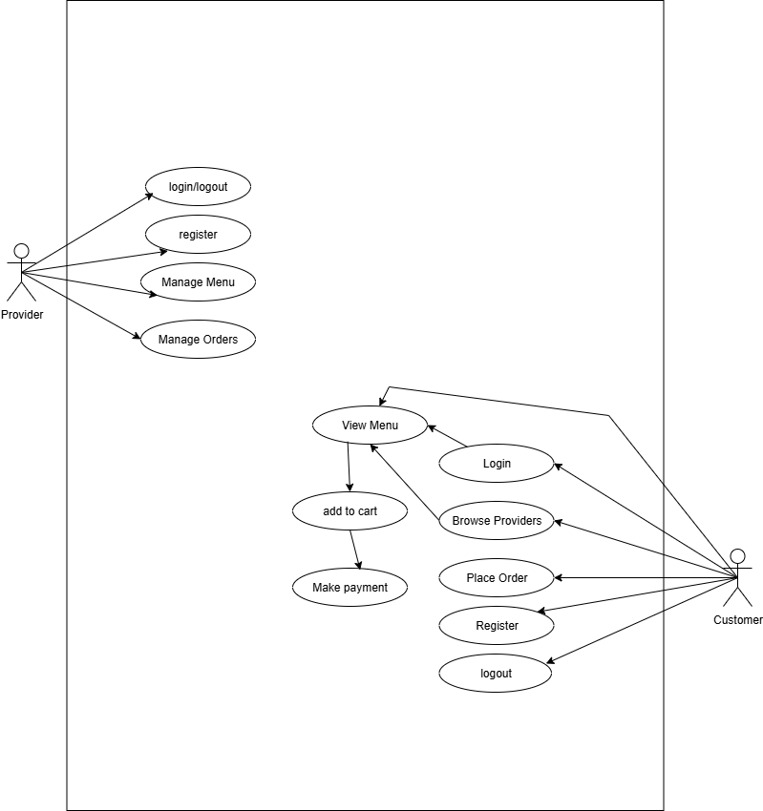

2.3 Entity Relationship Diagram
This Entity-Relationship (ER) Diagram models the data structure for a meal ordering system. Key entities are: User, who places an order; Provider, who offers Meal Plans; Cart, which holds the meal plans and order details; and Payment, which handles the transaction. The diagram shows how these entities relate to each other in the system.
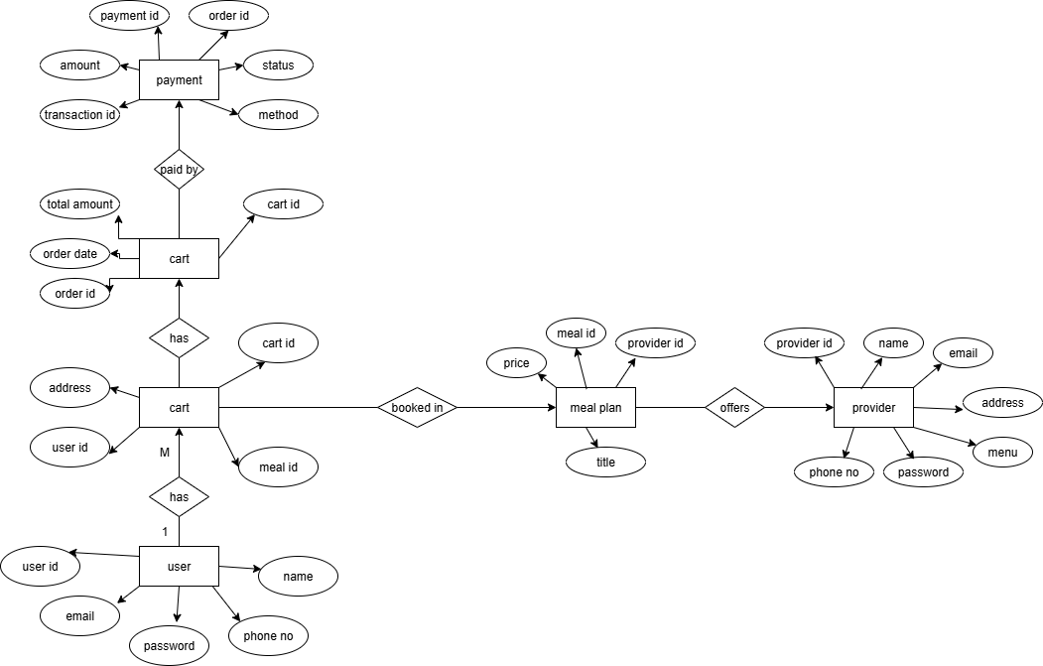

2.4 Activity Diagram
This Activity Diagram models the user's meal plan ordering process. It starts with login/registration and browsing. If plans are available, the user can add to cart, place the order, and proceed to payment. The flow concludes with a successful order confirmation and provider notification, or handles a payment failure by allowing a retry or cancellation.
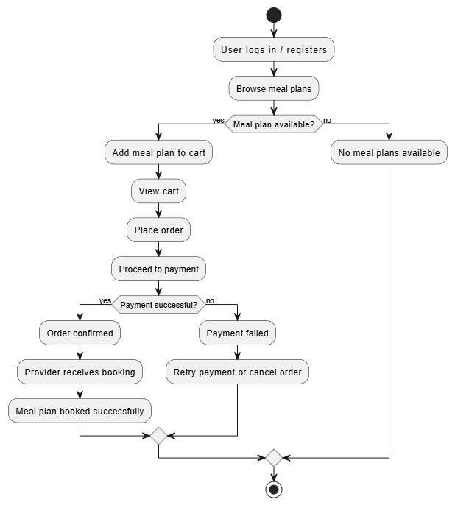

2.5 Class Diagram
This Class Diagram defines the structure of a meal ordering system. The core classes are User and Provider, interacting via the Cart to select Meal_Plans. The transaction is finalized as an Order, which is then linked to a Payment for processing. The diagram outlines the attributes and behaviors (operations) for each of these six entities.
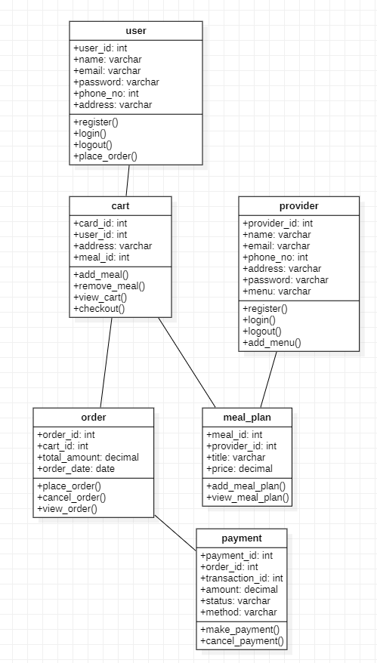
2.6 Object Diagram
This Object Diagram demonstrates a concrete scenario of a single successful transaction in the meal ordering system:
- User Object: user1 (Kaustubh, ID 101, Mumbai).
- Provider Object: provider1 ("Foodie Tiffins," ID 401, Mumbai).
- Meal Plan Object: mealPlan1 (ID 301, "Veg Thali," Price 250) is offered by provider1.
- Cart Object: cart1 (ID 201) is associated with user1 and includes mealPlan1.
- Order Object: order1 (ID 501, Total 250) is placed from cart1.
- Payment Object: payment1 (ID 601, Amount 250, Method UPI) is a "Completed" transaction that paid by order1
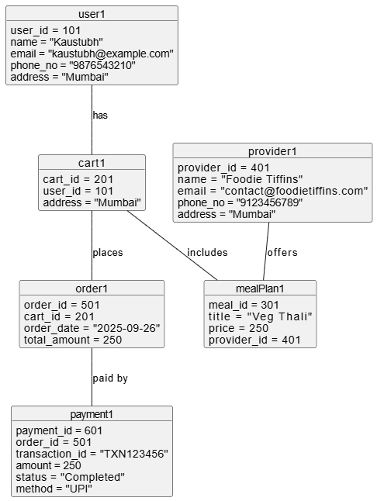

2.7 Sequence Diagram
This Sequence Diagram outlines the core steps of the Order Workflow:
- Selection and Cart Management: The User adds a meal to the Cart, which confirms the MealPlan selection. The User then places the order, prompting the Order object to retrieve cart details.
- Payment Processing: The User initiates payment with the Payment component, which verifies the transaction, confirms success with the Order object, and notifies the User.
- Booking Confirmation: The Order object sends details to the MealPlan component, which triggers a "Confirm booking" message to the Provider, finalizing the order lifecycle.
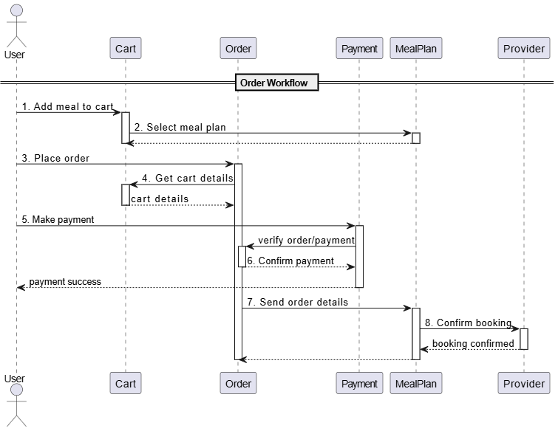

2.8 Collaboration Diagram
This Collaboration Diagram (or Communication Diagram) visually maps the Order Workflow by focusing on the flow and sequence of eight messages exchanged between the six key system objects: User, Cart, Order, Payment, MealPlan, and Provider.
The process begins with the User adding a meal to the Cart, which connects to the MealPlan object. The user then initiates the "Place order" message to the Order object. Next, the Order object orchestrates the payment process with the Payment object before sending the final order details to the MealPlan object. The workflow concludes when the MealPlan object sends a "Confirm booking" message to the Provider, completing the entire order lifecycle.
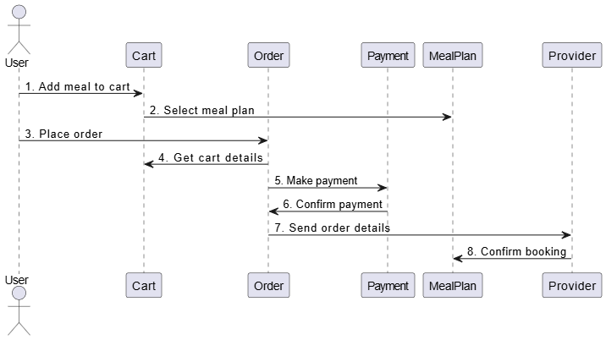

2.9 State Diagram
This State Machine Diagram outlines the core lifecycle of a user's order:
- Authentication: The system moves between LoggedOut and LoggedIn states.
- Order Creation: The user proceeds through Browsing to CartUpdated before entering the OrderPlaced and PaymentPending states.
- Fulfillment: Payment resolves to either PaymentSuccessful (leading to MealPreparation and completion) or PaymentFailed (allowing a retry loop).
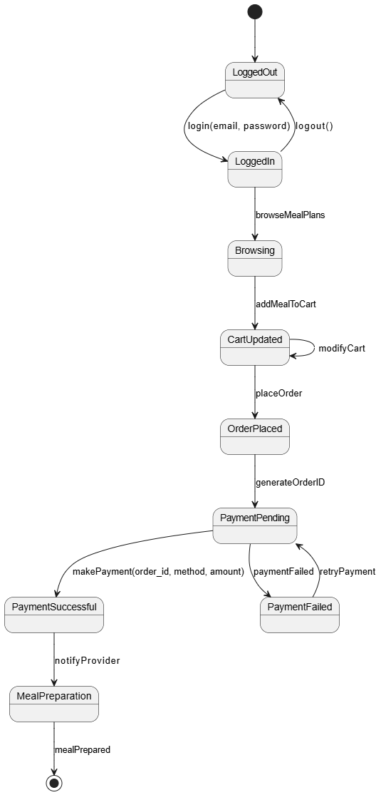

III. System Design

3.1 Component Diagram
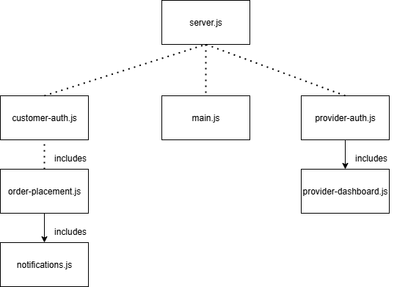
3.2 Package Diagram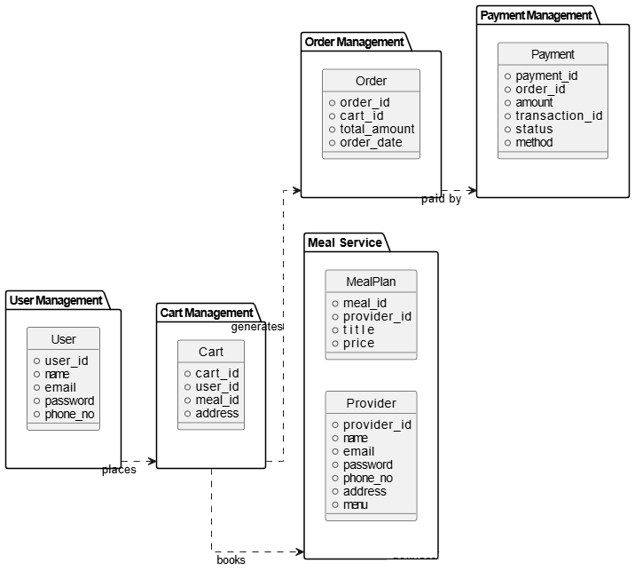

3.3 Deployment Diagram
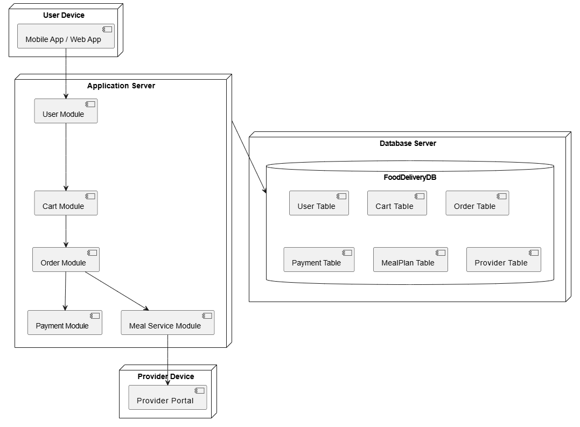

3.4 System Flow Chart
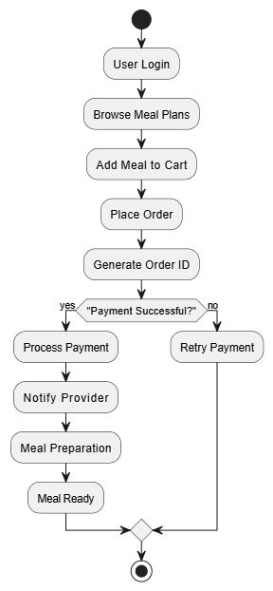

3.5 Structured Chart
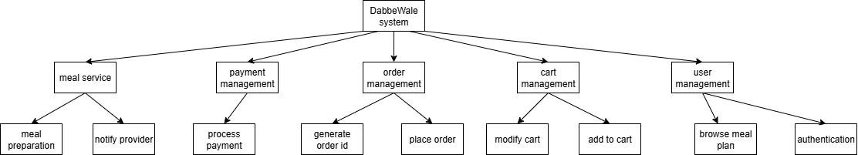

IV. System Coding

4.1 MENU TREE/SITEMAP
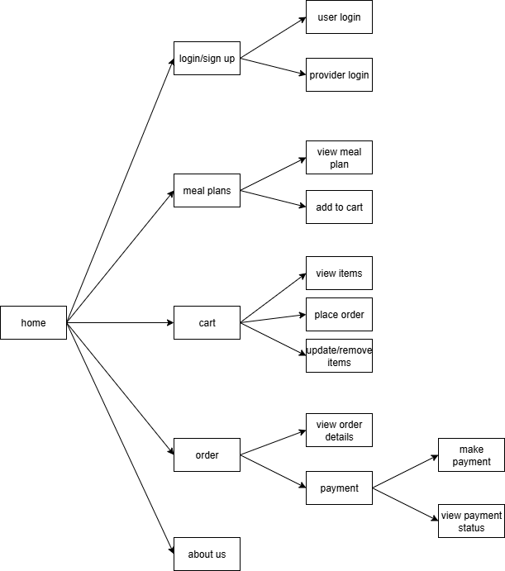
This diagram represents the navigational structure of the food ordering application, starting from the Home page. From Home, the user can access various sections of the system.
4.1.1 Home Page (Root Node)
- The central entry point of the application.
4.1.2 Login/Sign Up
- From here, the user can either:
  - User Login → for customers.
  - Provider Login → for meal providers.
4.1.3 Meal Plans
- This section allows the customer to:
  - View Meal Plan → browse available meal plans.
  - Add to Cart → add selected meals to their cart.
4.1.4 Cart
- Inside the cart, the customer has multiple options:
  - View Items → check what has been added to the cart.
  - Place Order → proceed with ordering.
  - Update/Remove Items → modify cart contents before finalizing.
4.1.5 Order
- Once an order is placed, the user can:
  - View Order Details → check summary of placed orders.
  - Payment → make payment for the order.
    - Make Payment → complete the payment transaction.
    - View Payment Status → check whether the payment succeeded or failed.
4.1.6 About Us
- Static informational section providing details about the company/service.
4.2 DATA DITCIONARY
Field | Type | Constraints
User
user id (PK) | INT | PRIMARY KEY, Auto Increment, Not Null
name | VARCHAR | Not Null
email | VARCHAR | UNIQUE, Not Null
Password | VARCHAR | Not Null
phone no | VARCHAR | Not Null
Cart
cart id (PK) | INT | PRIMARY KEY, Auto Increment, Not Null
user id (PK) | INT | FOREIGN KEY REFERENCES User(user id)
address | VARCHAR | Not Null
Order
order id (PK) | INT | PRIMARY KEY, Auto Increment, Not Null
cart id (PK) | INT | FOREIGN KEY REFERENCES User(user id)
total amount | DECIMAL | Check(total_amount>=0), Not Null
order date | DATE | Not Null
Payment
payment_id (PK) | INT | PRIMARY KEY, Auto  Increment, Not Null
order_id (FK) | INT | FOREIGN KEY REFERENCES  Order(order_id)
amount | DECIMAL | Check(amount>=0), Not Null
status | ENUM | Values(Pending, Completed, Failed), Not Null
method | VARCHAR | Not Null
transaction_id | VARCHAR | Unique, Not Null
Meal Plan
meal_id (PK) | INT | PRIMARY KEY, Auto  Increment, Not Null
provider_id (FK) | INT | FOREIGN KEY REFERENCES  Provider(provider_id)
title | VARCHAR | Not Null
price | DECIMAL | Check(price>=0), Not Null
Provider
provider_id (PK) | INT | PRIMARY KEY, Auto  Increment, Not Null
name | VARCHAR | Not Null
email | VARCHAR | UNIQUE, Not Null
password | VARCHAR | Not Null
phone_no | VARCHAR | Not Null
address | VARCHAR | Not Null
menu | TEXT | Nullable
Data Dictionary specifies how data is stored, organized, and constrained within the system’s database. It defines each entity in detail, including primary keys, foreign keys, data types, and integrity constraints.
4.2.1. User Table
- Fields: user_id (PK), name, email, password, phone_no
- Constraints:
  - user_id is auto-increment and primary key.
  - email must be unique and not null.
  - All fields are mandatory (Not Null).
4.2.2. Cart Table
- Fields: cart_id (PK), user_id (FK), address
- Constraints:
  - cart_id is primary key, auto-increment.
  - user_id references User(user_id).
  - address is required.
4.2.3. Order Table
- Fields: order_id (PK), cart_id (FK), total_amount, order_date
- Constraints:
  - order_id is primary key, auto-increment.
  - cart_id references Cart(cart_id).
  - total_amount must be ≥ 0.
  - order_date cannot be null.
4.2.4. Payment Table
- Fields: payment_id (PK), order_id (FK), amount, status, method, transaction_id
- Constraints:
  - payment_id is primary key, auto-increment.
  - order_id references Order(order_id).
  - amount must be ≥ 0.
  - status can only be Pending, Completed, or Failed.
  - transaction_id must be unique and not null.
4.2.5. Meal Plan Table
- Fields: meal_id (PK), provider_id (FK), title, price
- Constraints:
  - meal_id is primary key, auto-increment.
  - provider_id references Provider(provider_id).
  - price must be ≥ 0.
  - title is required.
4.2.6. Provider Table
- Fields: provider_id (PK), name, email, password, phone_no, address, menu
- Constraints:
  - provider_id is primary key, auto-increment.
  - email must be unique and not null.
  - menu can be nullable, other fields are required.

4.3 Design Patterns Used
4.3.1 Backend (Node.js/Express)
- Model-View-Controller (MVC) The backend structure is a classic example of the MVC pattern, adapted for a REST API.
  - Model: The models/ directory contains Mongoose schemas. These define the structure of the data (like User, Provider, Order) and handle all interactions with the MongoDB database. They represent the data and business logic layer.
  - Controller: The controllers/ directory handles the application logic. It receives incoming requests forwarded from the routes, processes them by interacting with the Models, and sends a response back to the client.
  - View (as API Routes): In a traditional web application, the View is the UI (e.g., HTML templates). For this REST API, the routes/ directory defines the API endpoints. The "view" is the JSON data that is rendered and sent back to the client.
- Middleware Pattern (Chain of Responsibility) Express.js is built heavily on the concept of middleware. The project explicitly has a middleware/ directory for authentication.
  - How it's used: Middleware functions are pieces of code that have access to the request (req), response (res), and the next middleware function in the application’s request-response cycle. They can execute code, make changes to the request and response objects, and end the cycle or pass control to the next middleware.
  - Example: The JWT authentication middleware checks for a valid token on protected routes. If the token is valid, it passes the request to the controller; if not, it sends an error response, effectively acting as a gatekeeper. This is a form of the Chain of Responsibility pattern.
4.3.2 Frontend (JavaScript)
- Module Pattern The project structure separates JavaScript logic into different files like main.js and provider-auth.js. Modern JavaScript (ES6+) encourages this through its native module system (import/export). This pattern is used to:
  - Encapsulate code into logical, private scopes.
  - Organize the codebase into smaller, maintainable files.
  - Avoid polluting the global namespace, which prevents naming conflicts.
- Observer Pattern (Implied) The README.md mentions a feature for "Real-time updates." While the exact implementation isn't detailed, this functionality typically relies on the Observer pattern.
  - How it works: A "subject" (like an order status manager) maintains a list of its dependents, called "observers" (like UI components). When the subject's state changes, it automatically notifies all its observers, which then update themselves. This is essential for features like live order tracking or dashboard updates without needing to refresh the page.
4.4 Source Code
index.html
login.html
register.html
style.css
\js\main.js
dabbewala-backend\server.js
const express = require("express");
const cors = require("cors");
const dotenv = require("dotenv");
const connectDB = require("./config/db");
dotenv.config();
const app = express();
// Middleware
app.use(express.json());
// Flexible CORS configuration for local development and production
const allowedOrigins = [
"https://dabbewale.netlify.app", // Production frontend
"http://localhost:8000", // Common local server port
"http://127.0.0.1:5500" // For Live Server extension
];
app.use(cors({ origin: (origin, callback) => {
// Allow requests with no origin (like mobile apps or curl requests) or from whitelisted domains
if (!origin || allowedOrigins.includes(origin)) { callback(null, true); }
else { callback(new Error(`Origin '${origin}' not allowed by CORS`)); }
}}));
// Connect DB (this already prints your custom logs!)
connectDB();
// Routes
app.use("/api/auth", require("./routes/authRoutes"));
app.use("/api/providers", require("./routes/providerRoutes"));
app.use("/api/orders", require("./routes/orderRoutes"));
// Test route for admin panel API check
app.get("/api/test", (req, res) => {
res.json({ message: "✅ API is reachable" });
});
// Health check route
app.get("/", (req, res) => {
res.json({ message: "✅ Server is running", timestamp: new Date().toISOString() });
});
// Start server
const PORT = process.env.PORT || 5000;
app.listen(PORT, () => {
console.log(`🚀 Server running on port ${PORT}`);
});
dabbewala-backend\config\db.js
const mongoose = require("mongoose");
// Fail fast rather than buffering model operations when disconnected
mongoose.set('bufferCommands', false);
const connectDB = async () => {
try {
console.log("🔌 Attempting to connect to MongoDB...");
console.log("📡 MongoDB URI:", process.env.MONGO_URI || "Not set - using default");
const mongoURI = process.env.MONGO_URI || "mongodb://localhost:27017/dabbewala";
await mongoose.connect(mongoURI, {
serverSelectionTimeoutMS: 20000, // wait up to 20s to find a server
socketTimeoutMS: 45000,
});
console.log("✅ MongoDB Connected Successfully!");
console.log("📦 Connected to database:", mongoose.connection.name);
console.log("🌐 MongoDB URL:", mongoose.connection.host + ":" + mongoose.connection.port);
} catch (err) {
console.error("❌ MongoDB Connection Error:", err.message);
console.error("💡 Make sure MongoDB is running and MONGO_URI is set correctly");
console.error("🔧 For local development, install MongoDB or use MongoDB Atlas");
process.exit(1);
}
};
module.exports = connectDB;

V. System Implementation

5.1 H/W and S/W Requirements
5.1.1. Software Requirements
The software requirements are categorized based on the environment: End-User (Client), Developer (Local), and Production (Hosting).
1. End-User Requirements (Client-Side)
These are the requirements for customers and providers to use the live application.
- Operating System: Any modern OS is supported.
  - Windows 10 or newer
  - macOS
  - Linux Distributions
  - Android
  - iOS
- Web Browser: An up-to-date web browser with support for HTML5, CSS3, and modern JavaScript (ES6+).
  - Google Chrome (recommended)
  - Mozilla Firefox
  - Microsoft Edge
  - Safari
- Internet Connection: A stable internet connection is required to access the live website and interact with the backend services.
2. Developer Requirements (Local Environment)
These are the tools and software needed for a developer to set up, run, and contribute to the project locally.
- Operating System: A developer-friendly OS.
  - Windows, macOS, or a Linux distribution.
- Version Control:
  - Git: For cloning the repository and managing code versions.
- Backend Stack:
  - Node.js: Runtime environment (includes npm for package management).
  - MongoDB: Database for storing application data. This can be set up in two ways:
    - MongoDB Community Server: For running a local database instance.
    - MongoDB Atlas: A cloud-hosted database service (recommended for ease of setup).
- Code Editor/IDE: Any modern text editor or Integrated Development Environment.
  - Visual Studio Code (recommended)
  - WebStorm
  - Sublime Text
- Local Web Server (for Frontend): An optional but recommended tool for serving the frontend files.
  - Python's built-in http.server
  - Node.js http-server package
3. Production Requirements (Deployment & Hosting)
These are the services used to host the live application.
- Frontend Hosting: A service for deploying static web content.
  - Netlify (as specified in README.md)
- Backend Hosting: A Platform-as-a-Service (PaaS) that can run a Node.js application.
  - Render (as specified in README.md)
  - Alternatives include Heroku, AWS, or a traditional VPS.
- Database Hosting: A production-grade, managed database service.
  - MongoDB Atlas (as specified in README.md)

5.1.2. Hardware Requirements
1. End-User Hardware
- Any device capable of running a modern web browser.
  - Desktop Computer
  - Laptop
  - Tablet
  - Smartphone
2. Developer Hardware
- A standard development machine (laptop or desktop) with sufficient resources.
  - Processor: A modern multi-core CPU.
  - Memory (RAM): 8 GB is recommended for a smooth development experience (running the database, server, and code editor simultaneously).
  - Storage: At least 10-20 GB of free disk space for project files, dependencies, and database storage.
3. Production Hardware
- This is fully managed by the cloud service providers (Netlify and Render). The hardware resources are allocated and scaled by the provider based on the chosen service plan and application traffic. The developer does not need to manage any physical hardware.

5.2 Screen / Report Layouts
Home Page
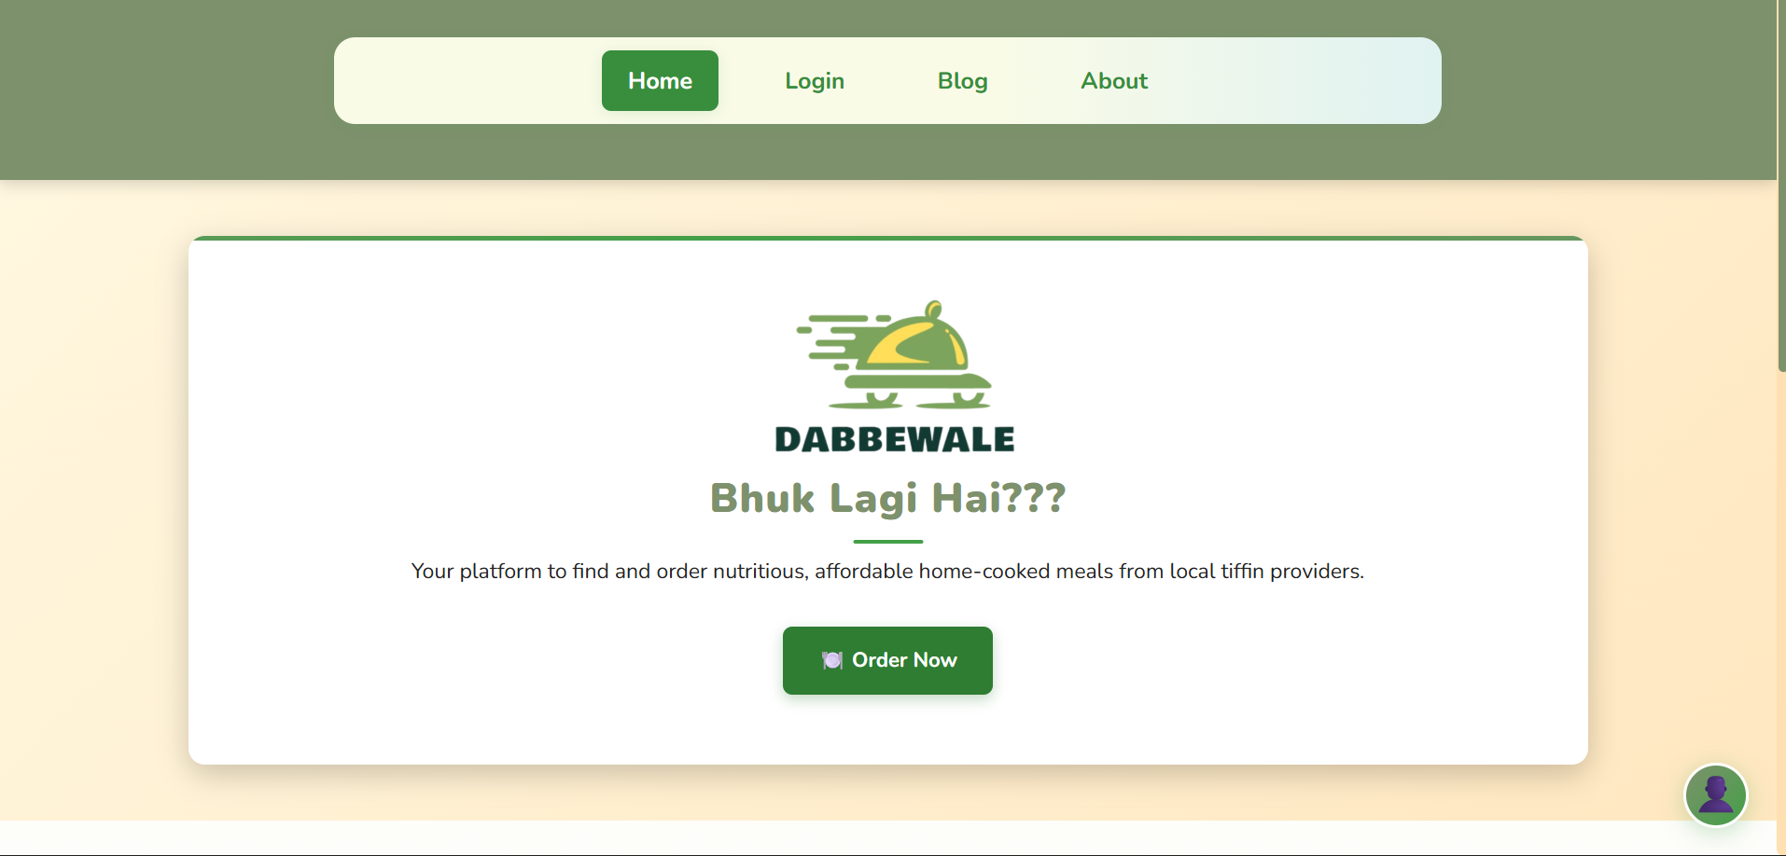
Footer & Testimonials
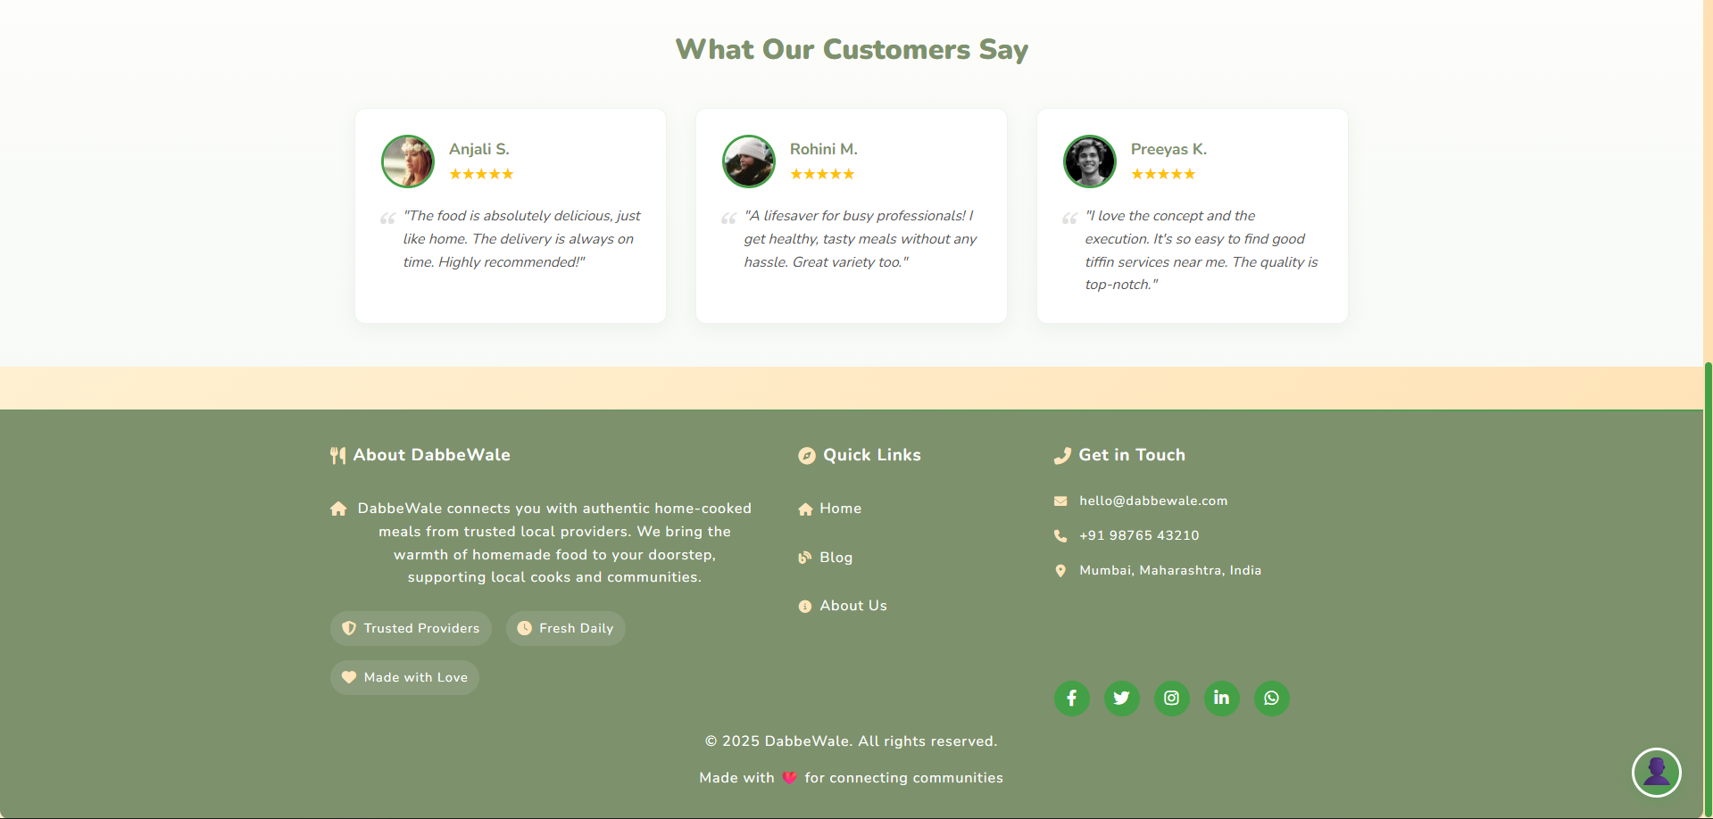
Login
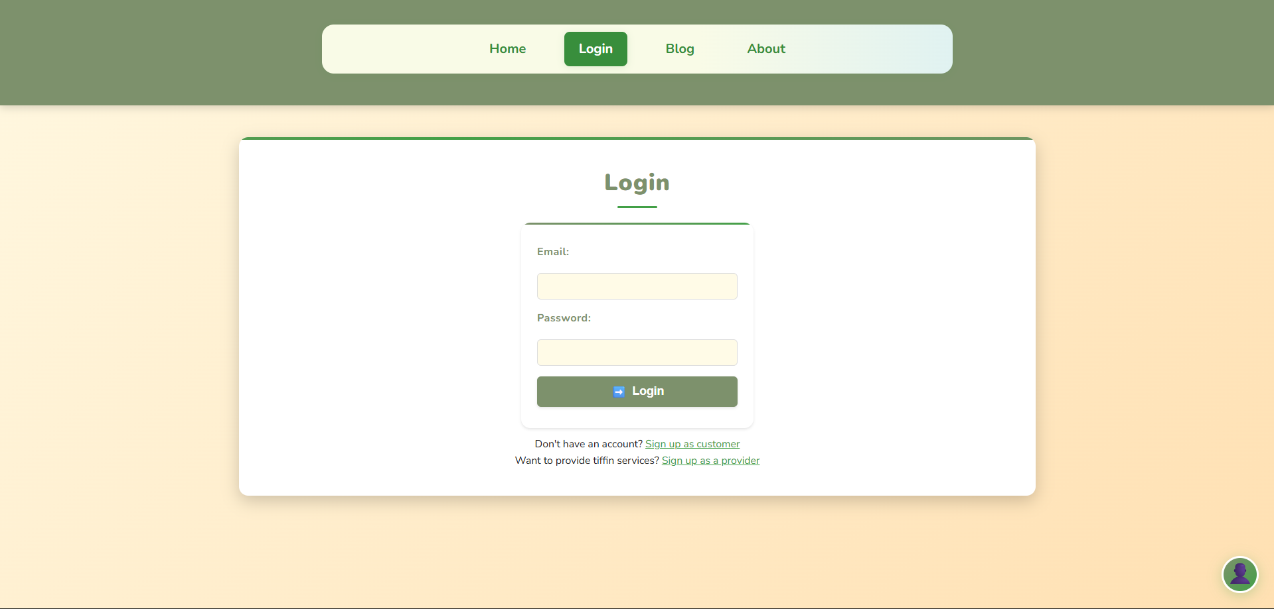
Customer Registration
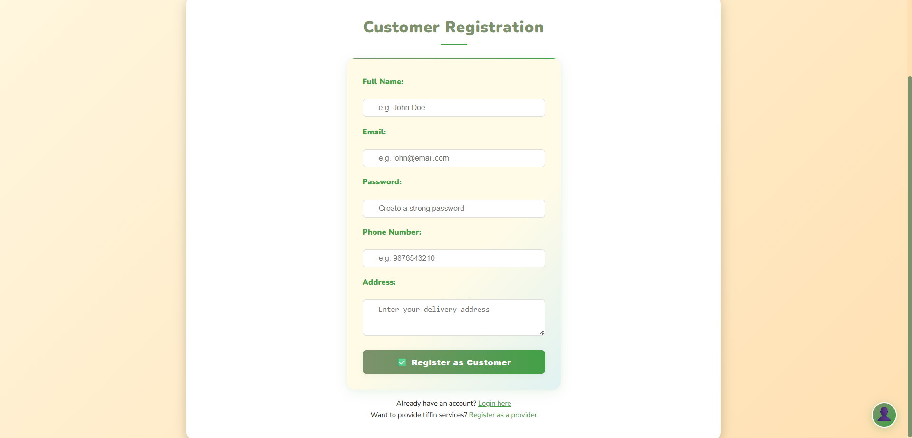
Provider Registration
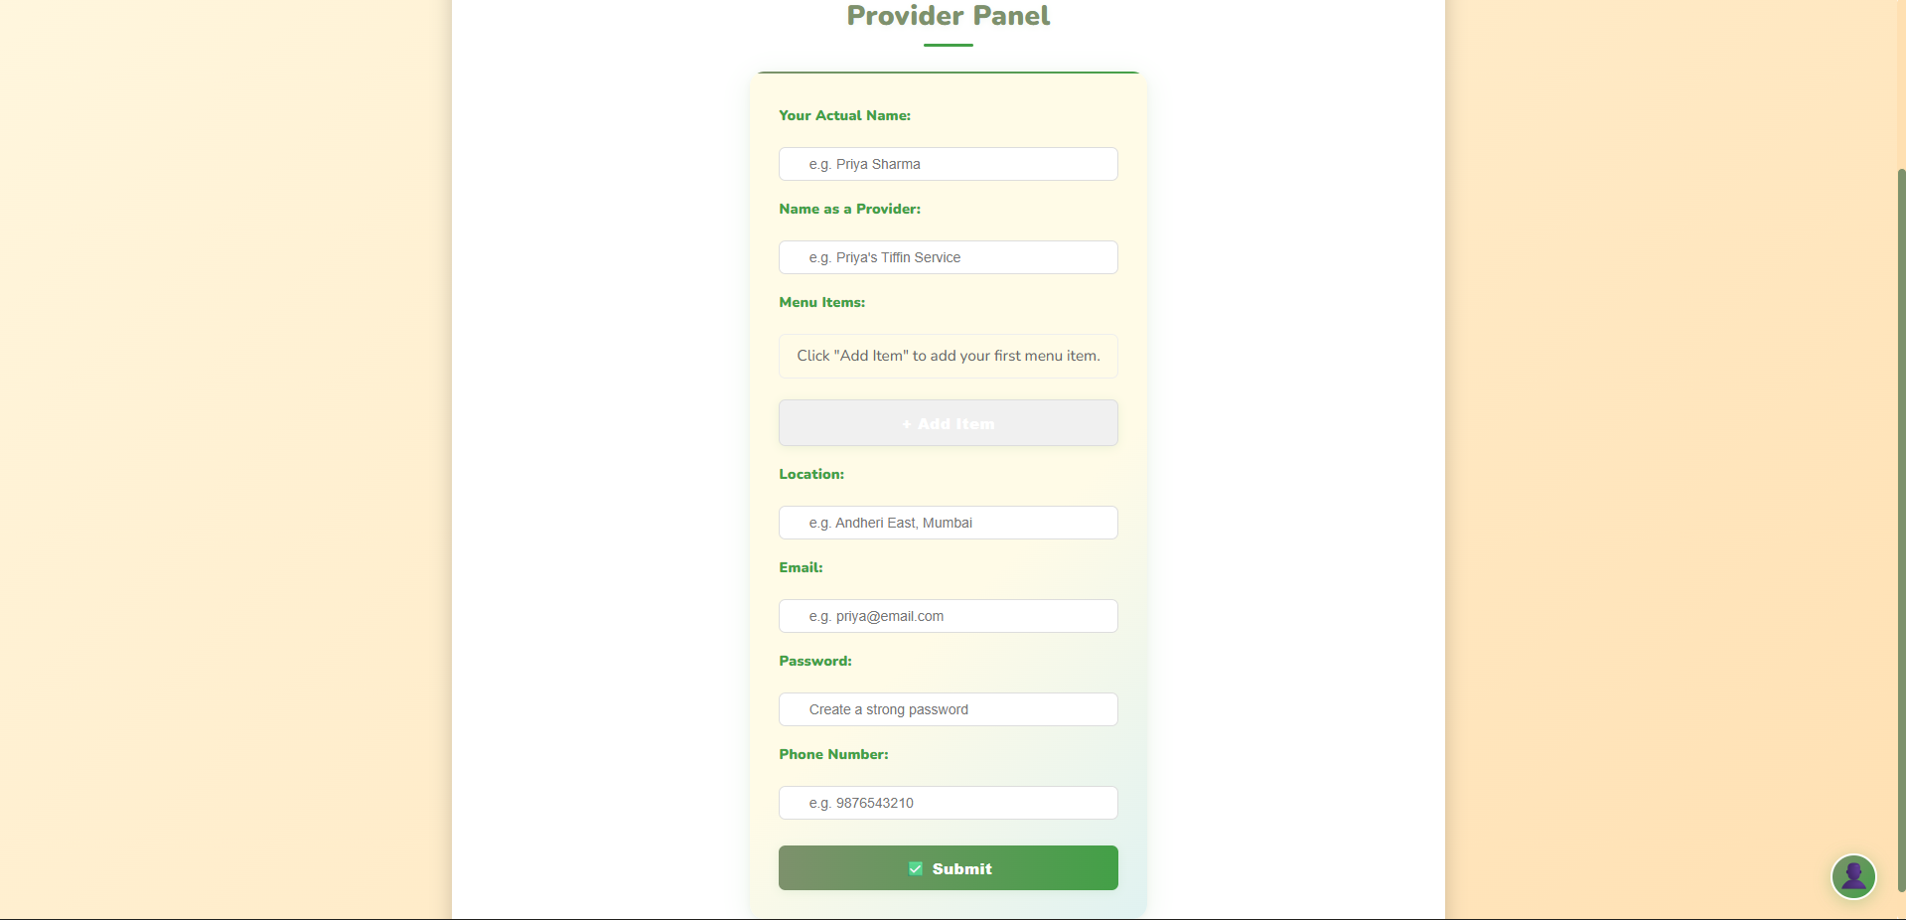
Order
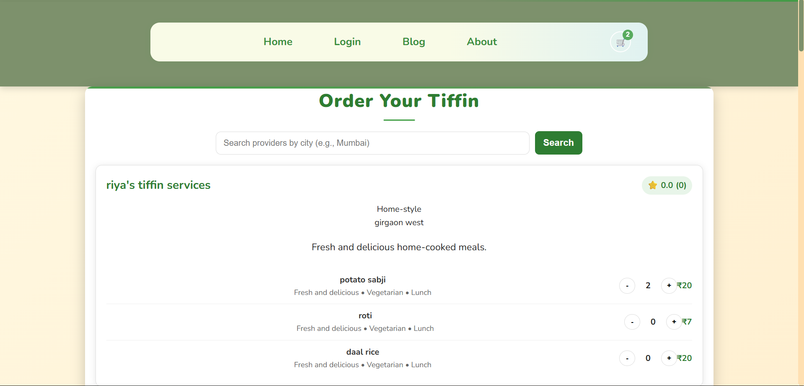
Cart
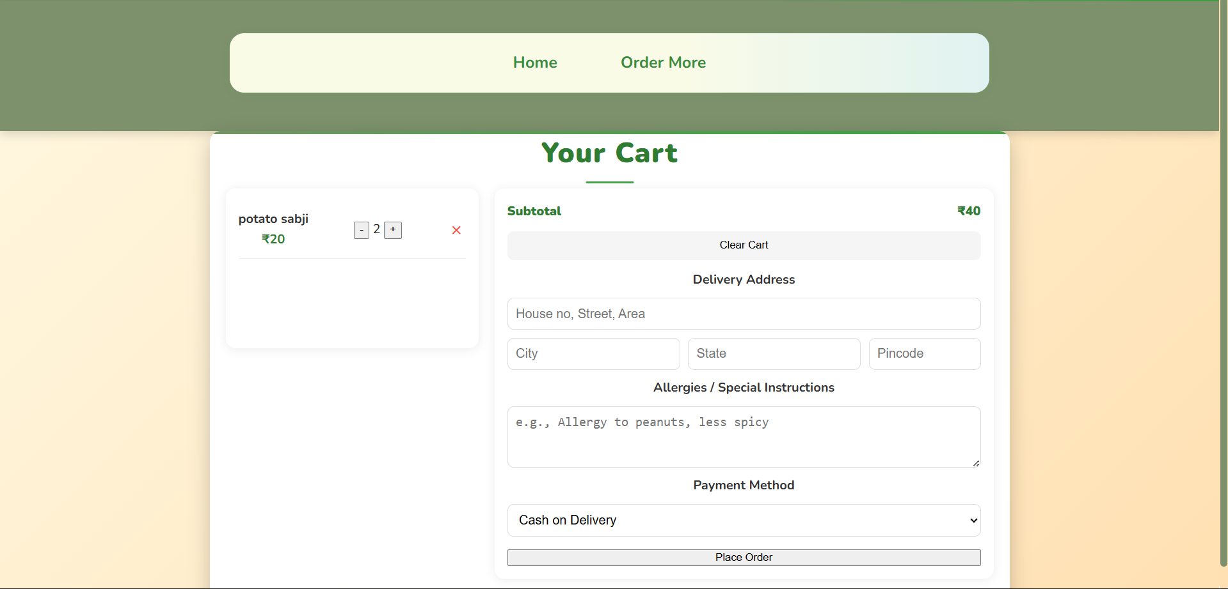

VI. Future Enhancements

6.1 Payment Gateway Integration
- Why: Automates payments, reduces manual work, builds trust.
- How: Use Razorpay/PayU with Node.js SDKs. Add initiate payment endpoint, handle webhooks for success/failure, and securely store transactions.
6.2 Rating & Review System
- Why: Builds trust and feedback loop for providers.
- How: Add rating and review fields to orders, create review API endpoint, show average rating on provider profile.
6.3 Order Tracking Enhancements
- Why: Makes updates more visual and engaging.
- How: Add live map (future mobile app) and granular statuses (Pending, Accepted, Preparing, Out for Delivery, Delivered, Cancelled).
6.4 Advanced Search & Filtering
- Why: Helps users find the right meals as providers grow.
- How: Extend /api/providers with filters for cuisine, diet, price range, and minimum rating.
6.5 Subscription Management
- Why: Supports weekly/monthly tiffin subscriptions, a key business model.
- How: Add subscription models linking users, providers, and plans. Build UI for subscribe/pause/resume/cancel. Automate order creation based on active subscriptions.
6.6 Comprehensive Admin Dashboard
- Why: Centralized control for managing the platform.
- How: Add protected admin section to view/manage users, providers, and orders. Handle disputes/refunds, onboard providers, and show analytics (revenue, sign-ups, etc.).
6.7 Promotions & Coupon System
- Why: Marketing tool to attract and retain customers.
- How: Create coupon model (code, discount type/value, expiry). Add validation logic in order process to apply discounts.

VII. References and Bibliography

- ReactJS – Frontend framework. https://reactjs.org
- Node.js – Backend runtime. https://nodejs.org
- Express – Server routing and APIs. https://expressjs.com
- MongoDB – Database management. https://www.mongodb.com
- GeeksforGeeks – Tutorials and guidance. https://www.geeksforgeeks.org

VIII. Annexures

8.1 Proposal
DabbeWale is a full-stack web app connecting home-based tiffin providers with customers seeking healthy, affordable meals. Inspired by Mumbai’s Dabbawalas, it offers a centralized marketplace with provider visibility, customer trust, and a reliable food solution. The live platform features a responsive UI, secure authentication, provider discovery, and order management.
8.1.1 Problem Statement
- Consumers: Struggle to access daily, healthy, and affordable meals; alternatives are costly or unhealthy.
- Providers: Talented home cooks lack visibility, marketing tools, and digital infrastructure to scale.
8.1.2 Proposed Solution
- Marketplace: Centralized platform for discovering verified tiffin providers, with location-based search.
- Provider Empowerment: Easy provider dashboard to manage menus, orders, and customers.
- Community Trust: Planned rating/review system for transparent, quality-driven growth.
8.1.3 Key Features
- Dual role system (Consumers/Providers).
- Secure JWT authentication with bcrypt password hashing.
- Location-based provider discovery.
- Provider panel for menu and service management.
- Responsive, mobile-first UI with light/dark mode.
- Basic order management system.
- Live deployment (Frontend: Netlify, Backend: Render).
8.1.4 Technical Architecture
- Frontend: HTML5, CSS3, JavaScript (ES6+); responsive UI; hosted on Netlify.
- Backend: Node.js + Express.js, MongoDB + Mongoose, REST API with MVC structure.
- Security: JWT authentication, bcrypt, CORS policy.
- Deployment: Hosted on Render.
8.1.5 Future Roadmap
- Payment Gateway Integration: Razorpay/PayU for automated payments.
- Rating & Review System: Customer feedback and provider insights.
- Advanced Search & Filtering: By cuisine, diet, price, rating.
- Subscription Management: Weekly/monthly plans.
- Admin Dashboard: Platform-wide control and analytics.
- Mobile App: Native/cross-platform apps with push notifications.

8.2 Phase Completion Table

8.3 Gantt Chart
